**Home Page**

1. The logo should be changed.





The new logo will be –

**N.B. – Logo Image is mailed**

1. The color of the marked menu bar should be transparent, not black.



1. 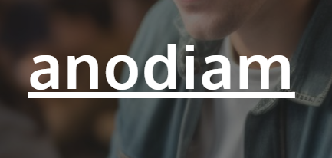

On the home page, the **anodiam** should go.We will give you a new background image.

**N.B. – The replacement image will be mailed**

1. Provide a login button on the header which should lead to the following url:

<https://www.anodiam.com/login>

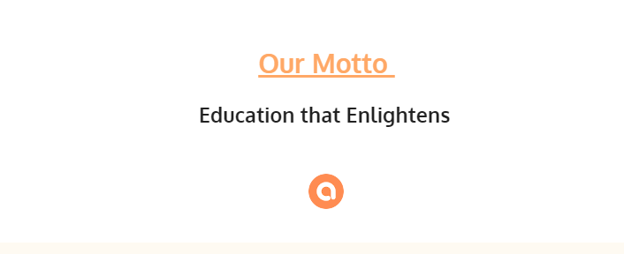

Include our services instead of “our motto”

1. Remove the logo from there.
2. **USE THIS SAME STYLE FOR WRITING ALL PAGE HEADERS, NO UNDERLINES.**



**About us**

1. Different picture for background image is mailed.



1. Images are given for About section.
2. The page looks too plain and unprofessional. Choose an attractive theme so that the contents stand out more.

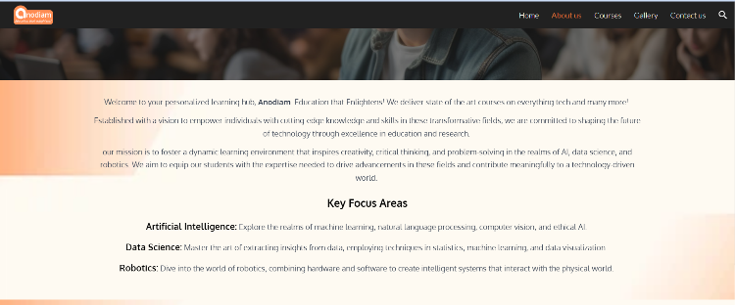

**Courses**

1. New background image and other images are mailed.



1. Make the para spacing uniform (Write the course name heading like : “**AI & Data Science**

**For Professionals**”

**If necessary)**

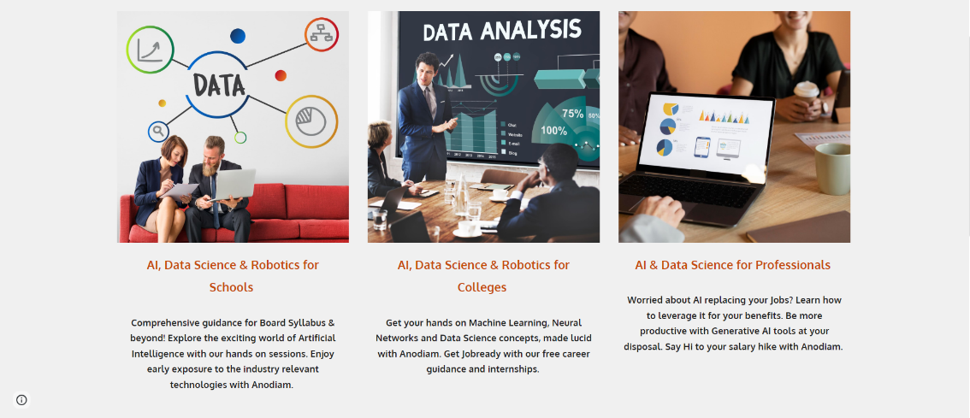

1. 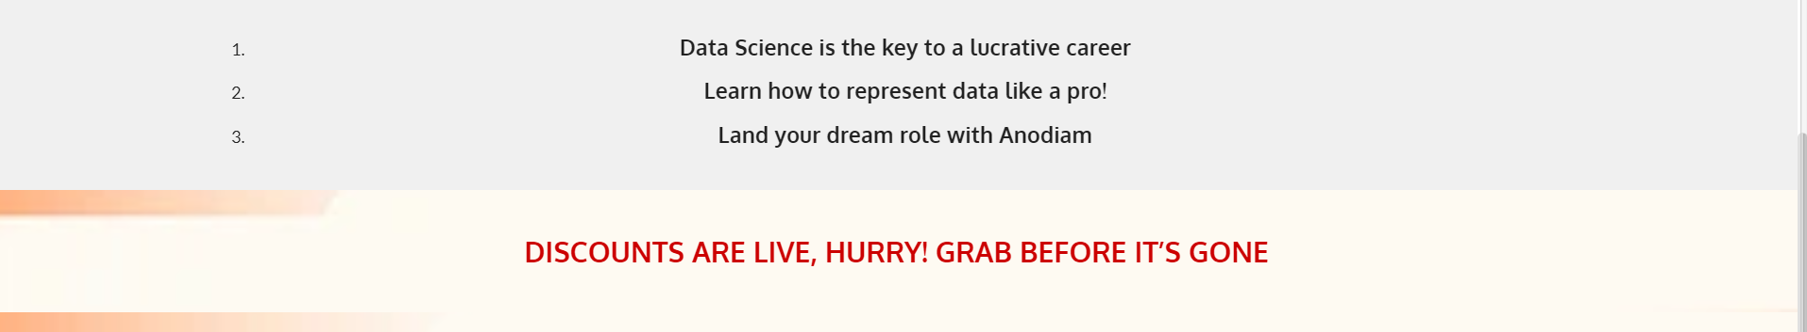Delete numberings.
2. Delete the “Discounts are…” totally.

**Gallery**

1. 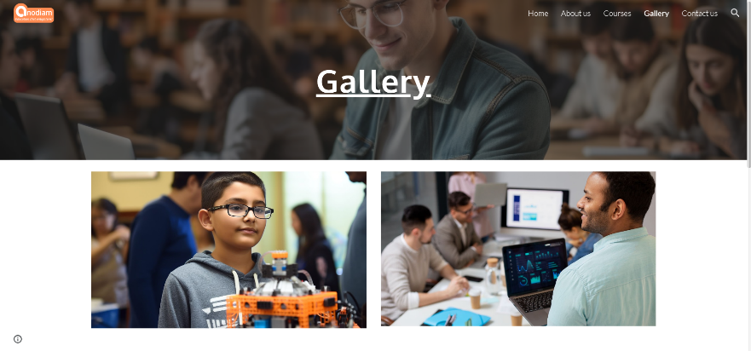Background image will be different and new images are attached.
2. Keep everything uniform and lined up. Move the reach us at part up.

**Contact us**

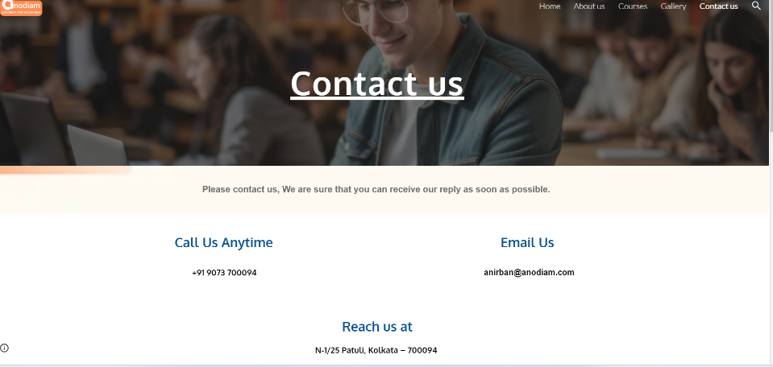

**Footer**

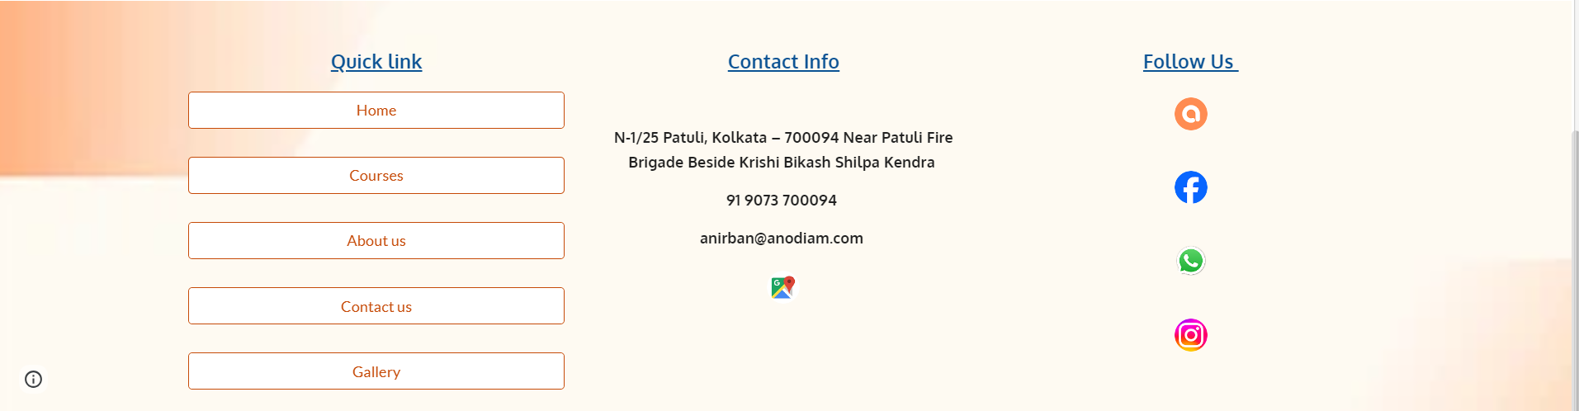

1. Quick link part is not necessary. The buttons are not needed either.
2. Give icons for address, mobile no. and email ID. Also turn them into hyperlinks so that clicking on them leads to the respective stuff.
3. Replace our app icon with playstore’s icon.
4. Find a better theme color and design for the footer.

**Web Tab**

1. 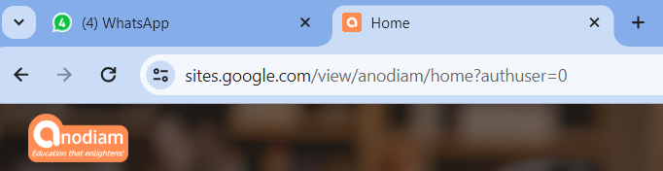Wrong choice of logo. Replace with the one from this mail.